User Response Prediction System using Machine Learning Techniques

Wireframe Documentation

**Vivek Limbad,**

**Manali Kadam,**

**Rueben Patil,**

**Siddhanth Ghag**

*Pursuing Masters in Data Science & Business Analytics.*

Homepage

On the Home page of the User Response Prediction System first, you will see the title of the project and we have mentioned our project teammates (right-hand side tab) and problem statement (left-hand side tab) along with our social media links.

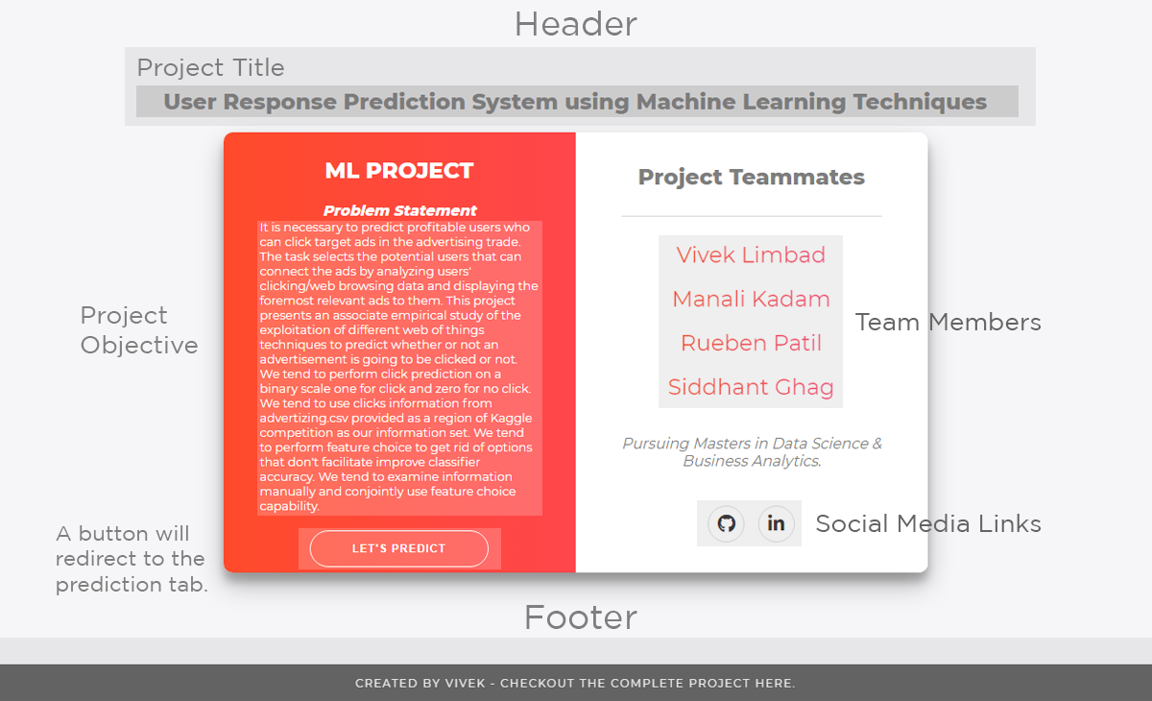

Img.1

When a user will click to LET'S PREDICT button it will automatically switch to the prediction tab.

Refer to image 2 for the prediction page.

Prediction page

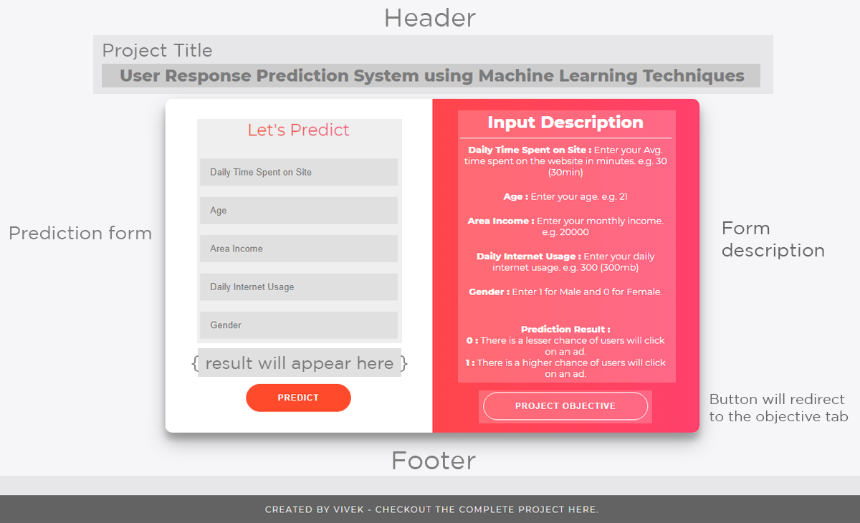

Img.2

So as you can see a prediction page is divided into two parts

On the left-hand side, we have created a form of our project concerning our datasets variables.

And on the right-hand side, we have described our input variables.

Prediction result

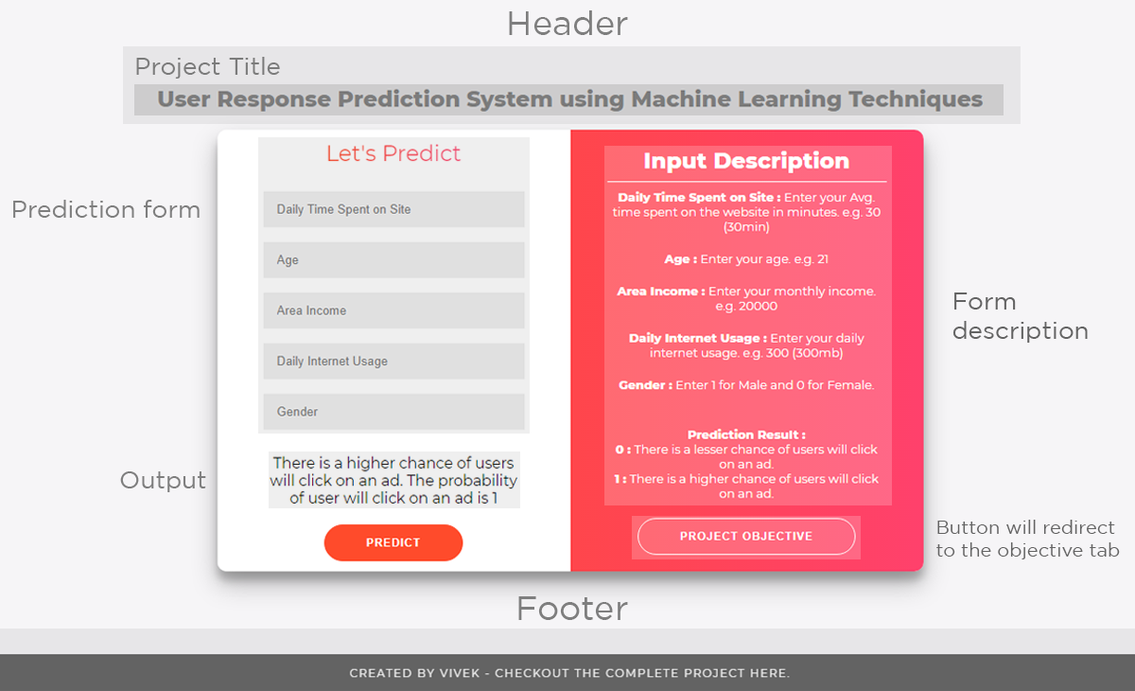

Img.3

This is how our Output lookalike.

Prediction results:

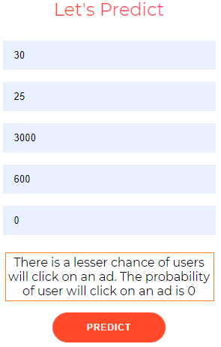

**0 :** There is a lesser chance of users will click on an ad.

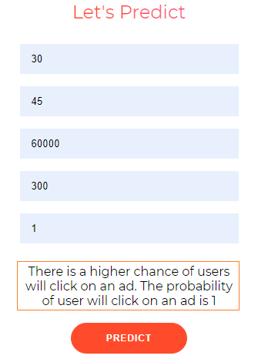

**1 :** There is a higher chance of users will click on an ad.

Form Validation

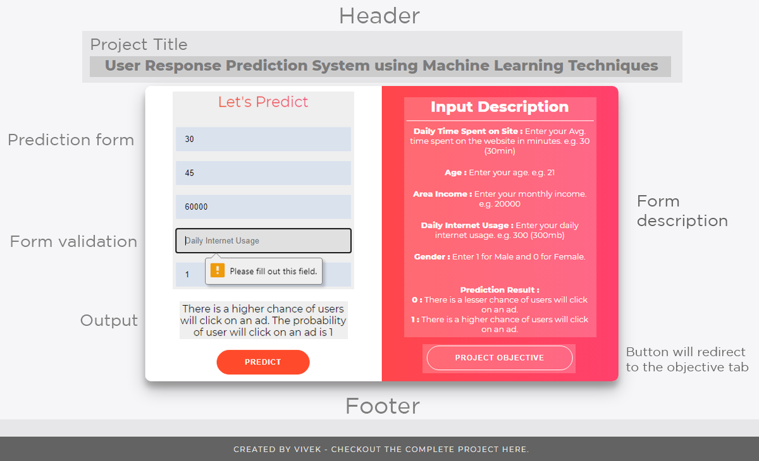

Img.4

You cannot leave any input filed blank.

Thank You !